DOCUMENTATION

ASSIGNMENT 1

STUDENT NAME: Chiorean Bianca Anamaria
GROUP:3

CONTENTS

1. Assignment Objective 3
2. Problem Analysis, Modeling, Scenarios, Use Cases 3
3. Design 4
4. Implementation 7
5. Results 9
6. Conclusions 9
7. Bibliography 9

Assignment Objective
The main objective of the assignment is to design and implement a polynomial calculator with a dedicate interface through which the user can enter polynomial, choose different operations (addition, subtraction, division, multiplication, derivation, integration ) to be executed and the result to be displayed.

The sub-objectives are:
- Designing a functional interface that corresponds with the requirements. (3)
- Identifying and using a corresponding data structure (Hash Map) (3)
- Implementing the operations (4)
  - Addition
  - Subtraction
  - Multiplication
  - Division
  - Derivation
  - Integration
- Testing the operations’ correctness (5)
- Identifying the scenarios of application usage and dealing with them (2)
  - incorrect input form
- Dividing the classes into packages under the rules of Model View Controller (MVC) software architecture pattern (3)

Problem Analysis, Modeling, Scenarios, Use Cases
The functional requirements are:
- Entering two polynomials in the corresponding text fields (see design) for the following operations
  - Summation
  - Subtraction
  - Multiplication
  - Division

- Entering one polynomial in the first text field for the next operations:
  - Integration
  - Derivation
Use case description:
Use case: calculate result of a polynomial operation
Primary actor: user/person who uses the calculator/student
Success Scenario Steps:
  - The user closes the information dialog box after reading the accepted polynomial input format
  - The user enters two polynomials (one is sufficient for the last two operations, integrations and derivation)
  - The user presses a button corresponding with the desired operation
  - The calculator checks if the input polynomials are valid
  - The calculator executes the asked operation
Alternative Sequence:
- Incorrect polynomial form
  - Return to step 2

Design
UML
Package diagram:
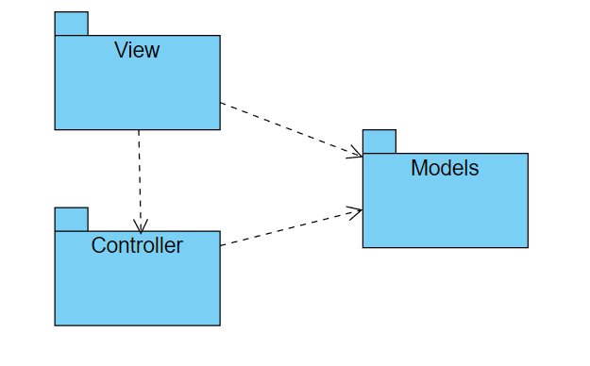

Class diagrams:
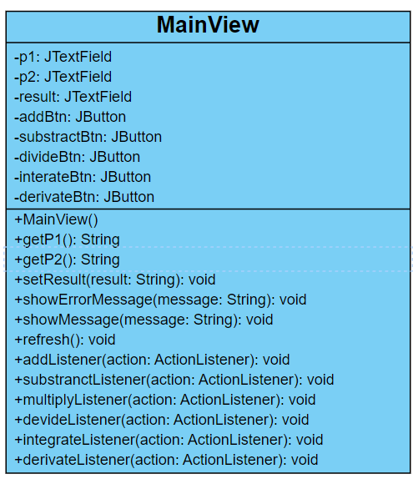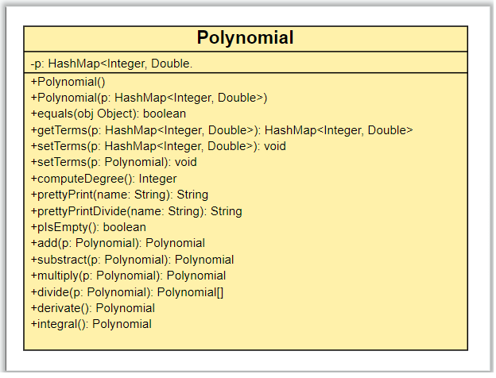
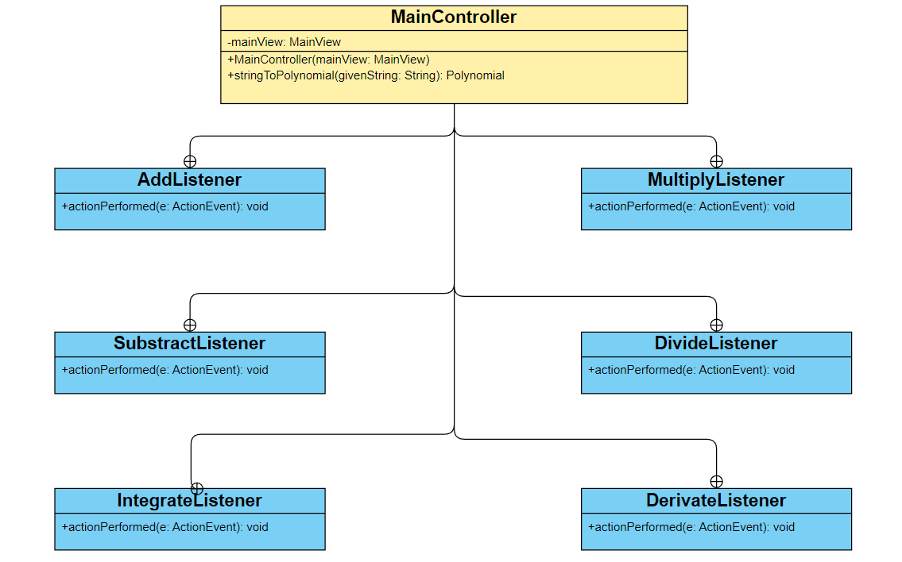

Employed data structure: HashMap<Integer, Double>, where the key has Integer type and the value of the entry is Double. HashMap was picked due to its property to store unique elements (in the standard case of entering a already existing key: the old value will be overwritten with the new value, in the current case: old value will become old value + new value). Elements (formed from key, value) can be accessed directly by knowing the key. This feature comes useful during the implementation of the required operations.

Interface:
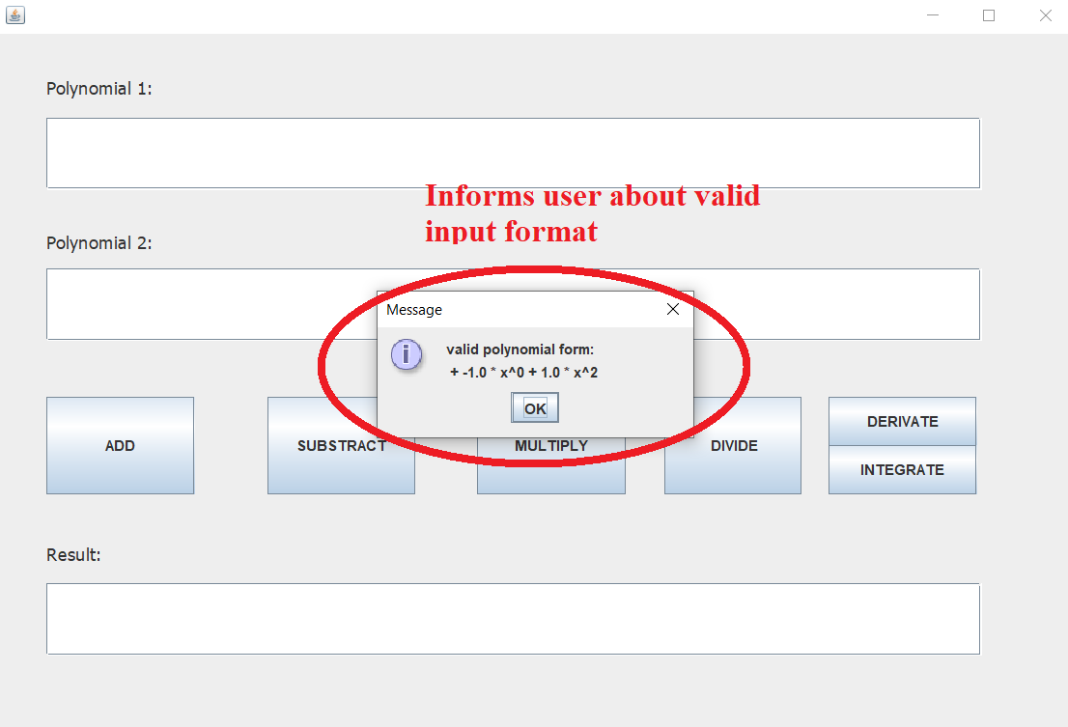

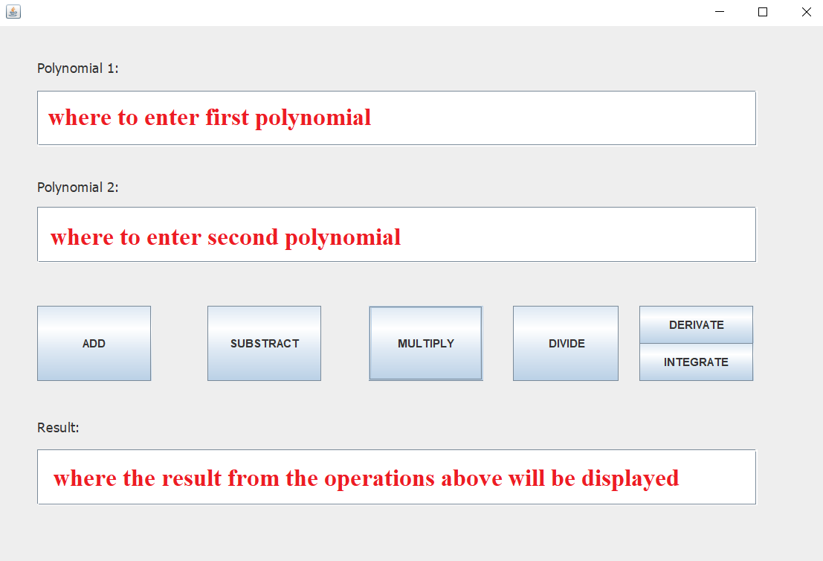
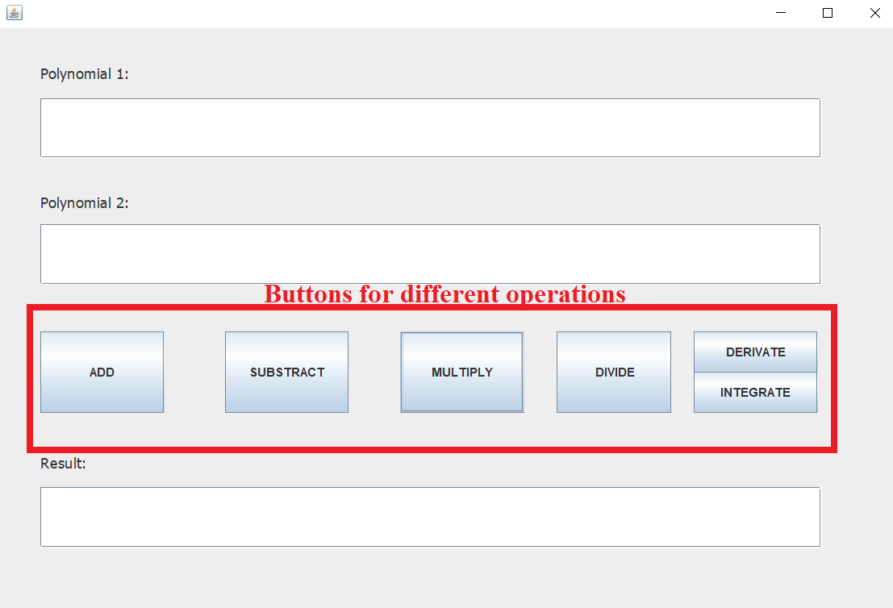
For the DERIVATE and INTEGRATE buttons only the first polynomial needs to be entered.

Implementation
The Polynomial class:
Contains a private field p with the type HashMap<Integer, Double>.
It has an empty constructor that creates a zero polynom.
The most important methods are:
- getTerms() which gives access to the pairs in the Hash Map.
- computeDegree() which returns the highest existing key
- prettyPrint() which prints/returns the polynomial and a string
- the operations
  - add
    - first, the first polynomial is put in the result polynomial
    - second, the coefficients of p1 are added with corresponding coefficients of p2
    - third, the pairs (key, coefficient) that exist only in p2 are added into the result polynomial
  - substract
    - multiply each value of the second polynomial with -1
    - use the add operation

  - multiply
    - multiply (add keys, multiply values) each term of the first polynomial with each term of the second polynomial
    - add the obtained monomials
  - divison P : Q = q r where q= quotient and r = remainder
    - the divison is possible while the degree of P is larger than degree of Q
    - q = with how much Q need to be multiply by to be equal with highest monomial of P (raised to the greatest power)
    - r = P – Q*q
  - derivative
    - iterate through the polynomial and for each existing monomial, the following monomial is put into the result: (key-1, valueOf(key) * value)
  - integral
    - iterate through the polynomial and for each existing monomial, the following monomial is put into the result: (key-1, value / valueOf(key+1))

The MainView class:
- It contains the interactive elements of the interface (text fields and buttons)
- The constructor that “draws” the actual interface
- Need getters and setters
- Error messeges
- Listeners used to detect “movement”- these are abstract methods

The MainController:
- Has as instance variable a MainView object that it controls
- The constructor
- Method to make a corresponding string into a polynomial
- Classes for Listeners that contain the logic when a button is pressed

The Main class: this is where the actual view and the controller are created for user usage.

The PolynomialTest class: the correctness of operations is tested.

Results
The testing scenarios are:
- Add:
  - P1 = + 3
  - P2 = 20* x^2
  - Expected result = 3.0*x^0 + 20.0*x^2
- Subtraction
  - Same polynomial as before
  - Expected result = 3.0*x^0 + - 20.0*x^2
- Multiplication
  - P1 = + 1.0 * x^0 + -1.0 * x^1 + 3.0 * x^2
  - P2 = + -2.0 * x^0 + 1.0 * x^1
  - Expected result = + -2.0 * x^0 + 3.0 * x^1 + -7.0 * x^2 + 3.0 * x^3
- Division
  - P = + -1.0 * x^0 + 1.0 * x^2
  - Q = + 1.0 * x^0 + 1.0 * x^1
  - Quotient = + -1.0 * x^0 + 1.0 * x^1, Remainder = 0
- Integration
  - P = + 5.0 * x^0 + 1.0 * x^3
  - Expected result = + 5.0 * x^1 + 0.25 * x^4
- Derivation
  - P = + -5.0 * x^0 + 6.0 * x^1 + -2.0 * x^2 + 1.0 * x^3
  - Expected result = + 6.0 * x^0 + -4.0 * x^1 + 3.0 * x^2
All the tests passed.

Conclusions
Developing this application I learned to prioritize my tasks, work in parallel (developing the interface and the operations), divide the work load. I observed how important are the comments in the code for documentation, the importance of suggestive variable, methods, classes names.

Bibliography
- https://online.visual-paradigm.com/diagrams/templates/
- https://www.geeksforgeeks.org

